***Racetastic!***

*Developed by: M. van den Nieuwenhoff, T. Keesmaat, H. Loman, R. Zwiep*

**Index**

1. Introduction
2. Style Guide
3. Gallery
4. Final Product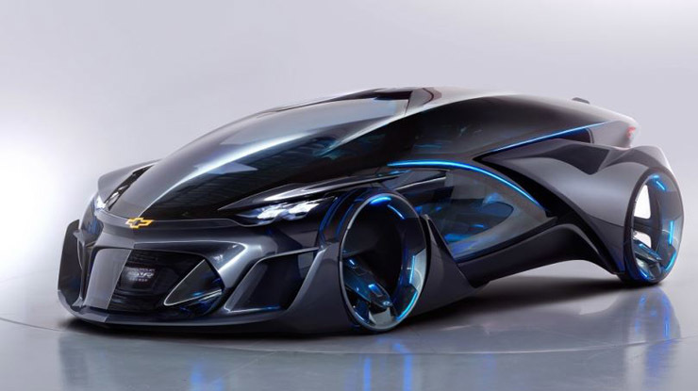

**Introduction**

Original Concept:

Racetastic is a 3rd person futuristic stylized multiplayer racing game. You race against the opponent which can either be a ghost of your own previous high score or a friend you play with through Split-screen multiplayer. You race through the streets of a futuristic city and the corridors a Spaceship in far outer space hopping between them through warp gates. You can pick up Power-Ups that give you various advantages such as: Speed Boost, Tracking Rockets, Smoke Field, Shortcut, and other Power-Ups of that kind. There are 3 usable vehicles: The Gait Wagon, The Mach Jet and The Velo Bike. Each vehicle has 3 skins: Base which are the regular colors for the vehicle, Branded Which recolors the Vehicle and features many brand stickers on the car and Prestige which coats the vehicle in precious gold. The Branded and Prestige skins are both unlocked by Picking up 50 Power-Ups with one vehicle and beating your own record time on one map with one vehicle 5 times respectively.  
  
Current Concept:

Racetastic is a 3rd person futuristic stylized racing game. You race through the streets of ONFC (Originally Named Futuristic City) jumping through portals that teleport you to other parts of the city. You can pick up speed boosts along the way to speed up your lap time and beat your last record. Every race you finish you get a set amount of tokens, these can be used to buy different skins and vehicles.

Work division:

Mathijs: Scrum, Artist

Thomas: Environment Artist

Hidde: Programmer  
Ramon: Programmer/UX

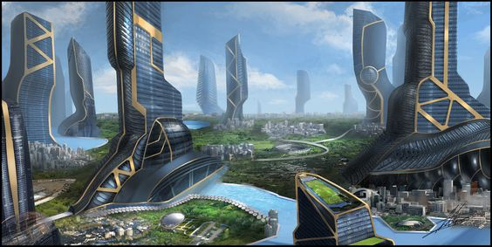***Style Guide***



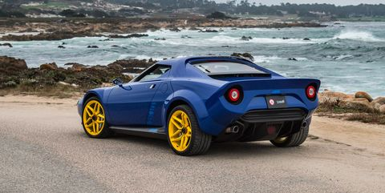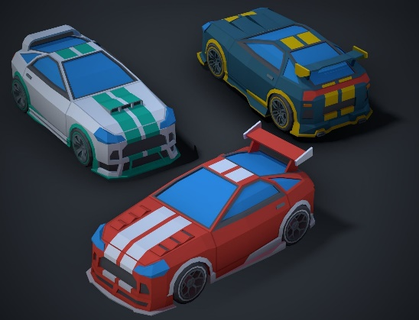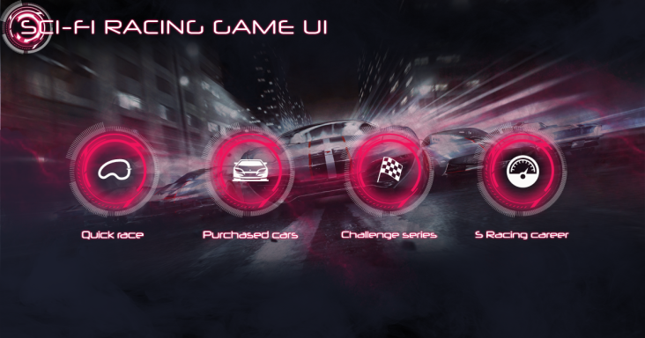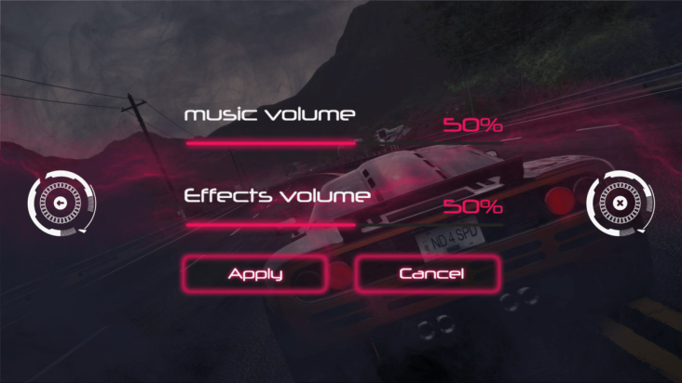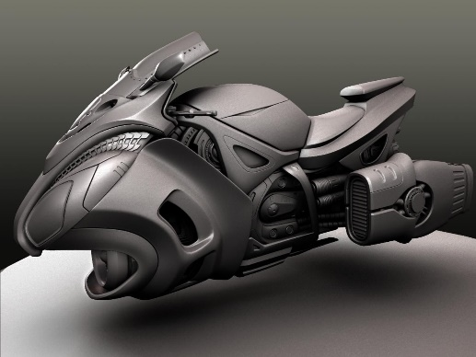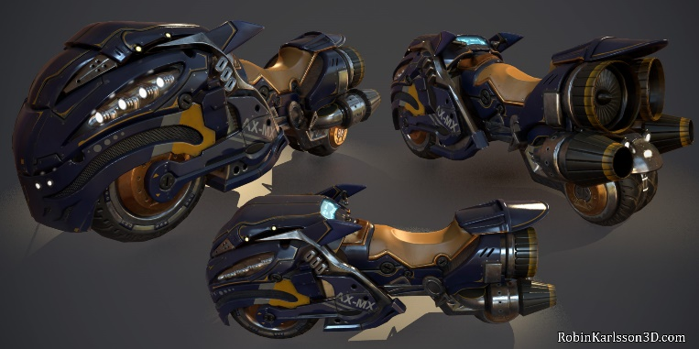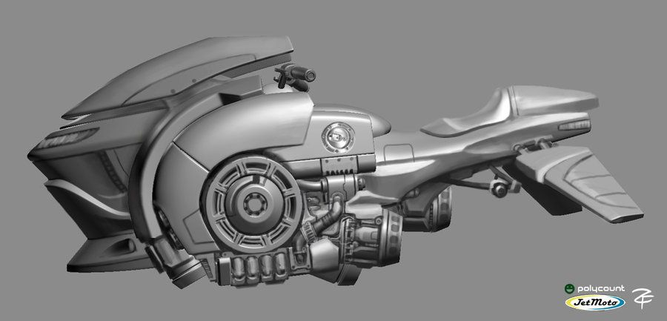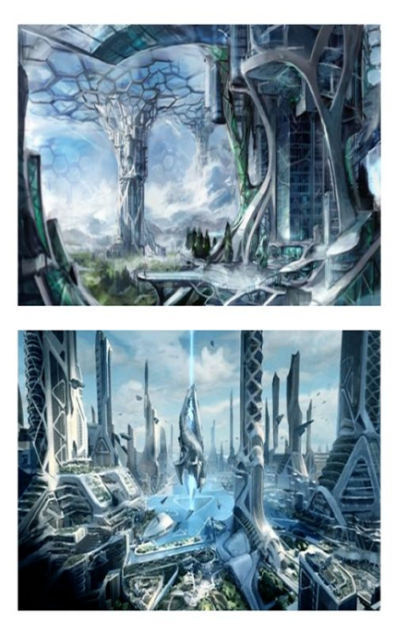***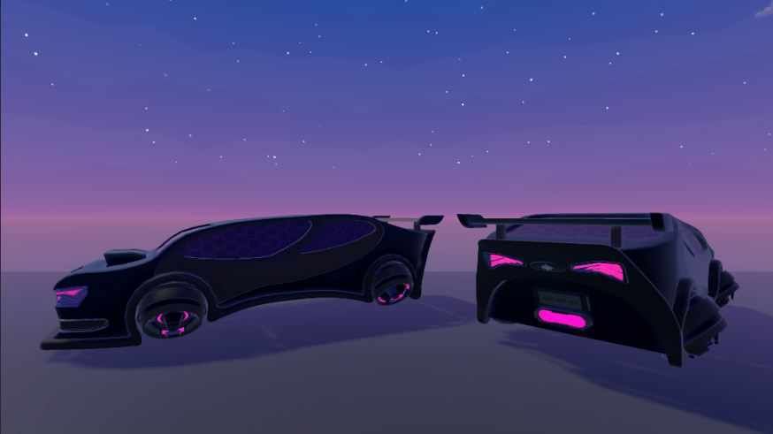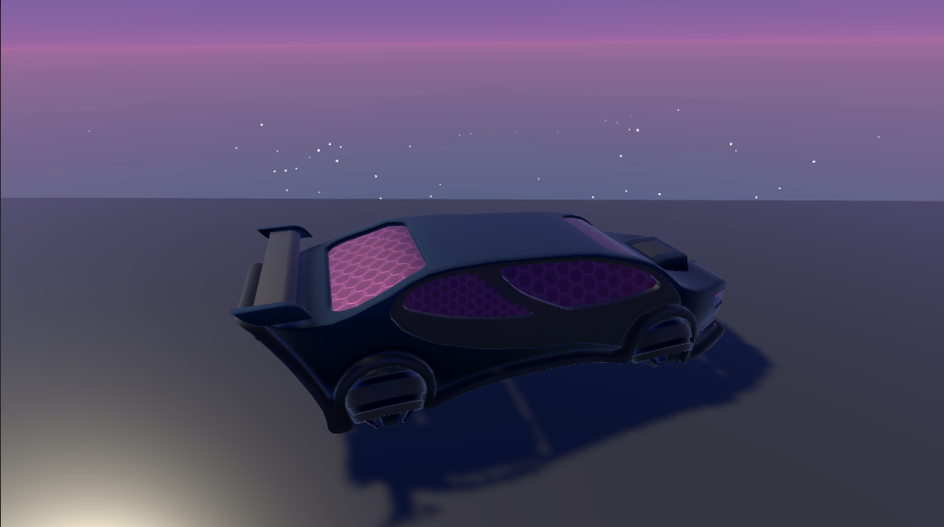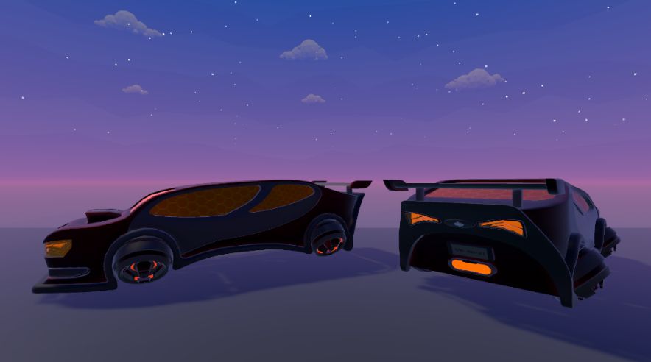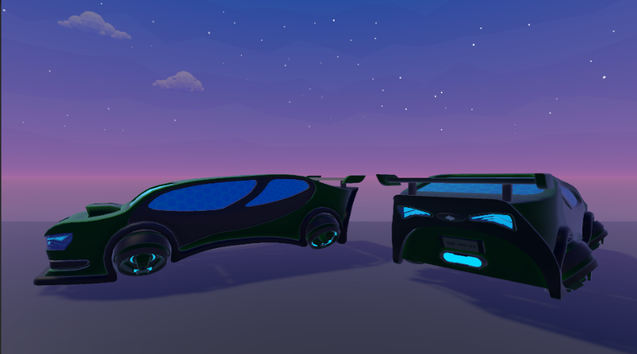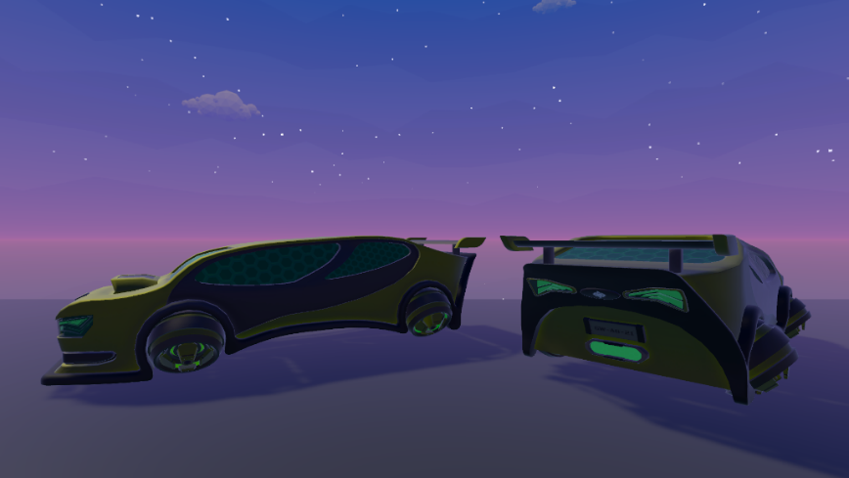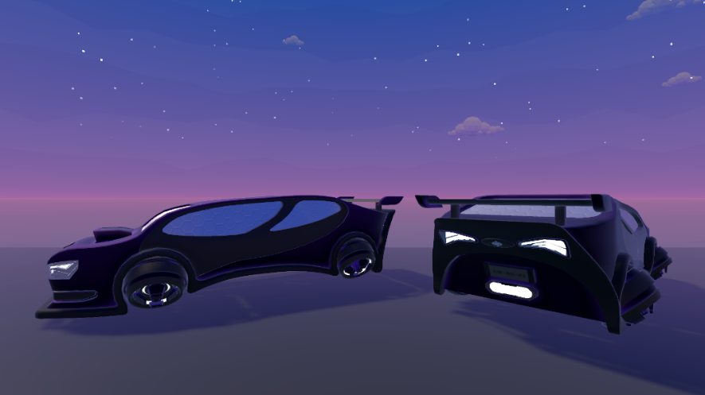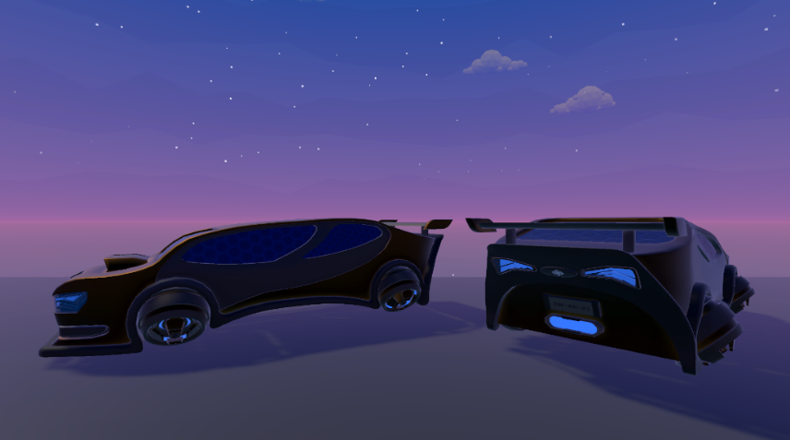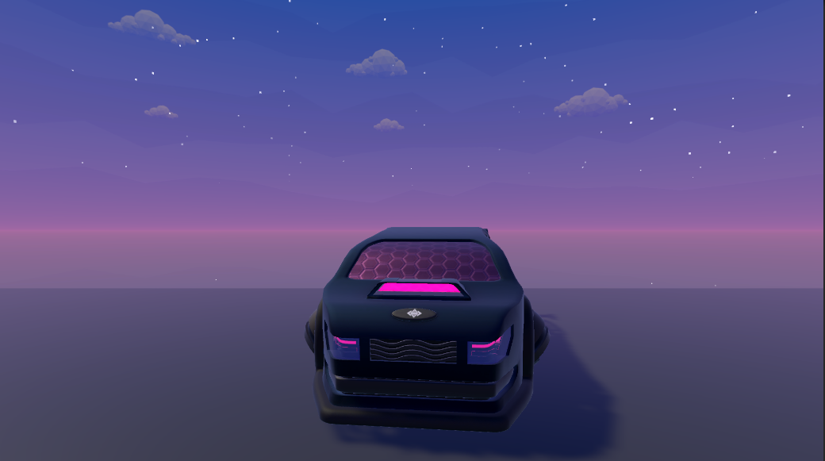Gallery***

